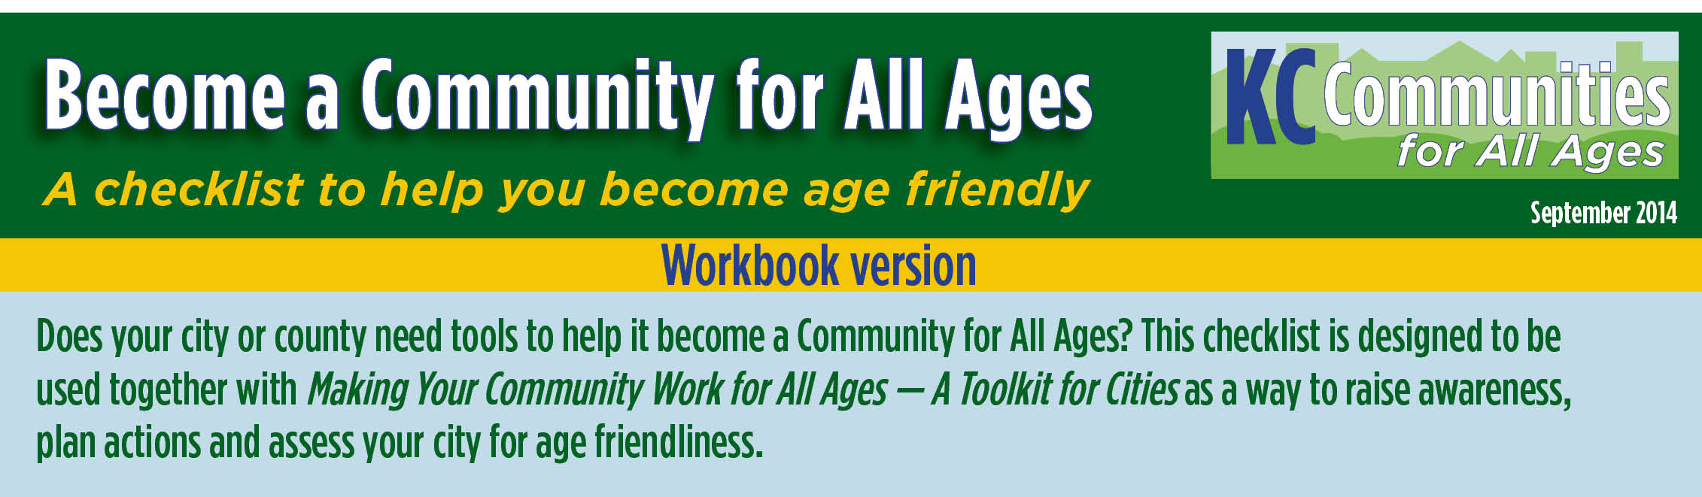
This Workbook is designed to assist committees assigned to document progress on their city’s age-friendly self-assessments using the Communities for All Ages Checklist. Enter progress information, notes, statistics, to-do lists, etc., in the green text boxes corresponding to each Policy and Action Item.
A final version of this Workbook may be used to support your application to the KC Communities for All Ages recognition program.
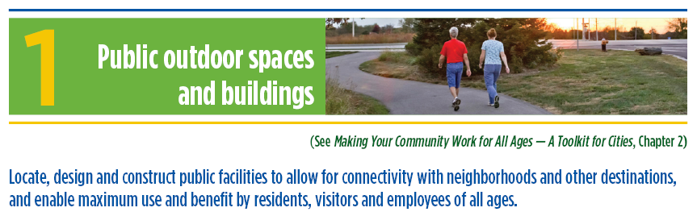
Cities are responsible for the location, design and construction of parks, trails, community centers, city halls and other public facilities and spaces. Most communities have assessed these facilities to ensure compliance with the Americans with Disabilities Act (ADA), and some have taken steps to make improvements beyond the minimums established by ADA.
Physical limitations and mobility needs must be considered when designing and creating both outdoor spaces and buildings. Residents with physical limitations are more comfortable, safe and active when communities consider and address their needs in the design of public buildings and spaces. The following policies and actions provide guidance on maximizing physical accessibility to public spaces for all levels of ability and age.

Policy
1-A The city develops and implements age-friendly policies that consider the needs of persons of all ages in the siting, design and development of public spaces. Examples include: parks and other outdoor spaces, walkways, outdoor seating, streetscapes and buildings.
___ Existing policies. (Please cite and attach copies for documentation.)
Use this space to record notes and progress on policy action to be undertaken.

1-B The city plans and constructs bike and pedestrian facilities to maximize use and safety for all users. Examples include: width, surface material and expected use. The city may use the American Association of State Highway and Transportation Officials’ (AASHTO) Highway Safety Manual standards or other recognized standards for bicycle and pedestrian facility design.
___ Included in city plans. (Please cite and attach copies for documentation.)
Use this space to record notes and progress on policy action to be undertaken.

1-C The city designs and builds its public buildings to meet the needs of residents of all ages. Examples include: easy-to-read signage and accessible elevators, ramps, railings and stairs, and non-slip floors.
___ Included in city plans. (Please cite and attach copies for documentation.)
Use this space to record notes and progress on policy action to be undertaken.

1-D The city prioritizes safety in parks and neighborhoods. Examples include: providing good street lighting, trimmed trees and bushes and other appropriate safety measures.
___ Included in city plans. (Please cite and attach copies for documentation.)
Use this space to record notes and progress on policy action to be undertaken.

1-E The city involves residents of varying ages and abilities in planning for the siting and design of public outdoor spaces and buildings.
___ Included in city plans. (Please cite and attach copies for documentation.)
Use this space to record notes and progress on policy action to be undertaken.

Action
1-F The city provides seating areas in public outdoor spaces and outside public buildings in recognition that residents have different levels of mobility and stamina.
___ Completed. (Please provide documentation.)
Use this space to record notes and progress on current actions.

1-G Stairways on public property, including within park facilities, are designed and constructed to maximize safety. Examples include: railings and painted or taped stair tips to distinguish each step.
___ Completed. (Please provide documentation.)
Use this space to record notes and progress on current actions.

1-H The city provides ample parking and drop-off areas near the entrances to public facilities that meets mobility and accessibility needs of all citizens. (ADA requirements are an expected minimum, the composition of the community and the expected use of a facility may dictate additional spaces to improve resident experience at public facilities.)
___ Completed. (Please provide documentation.)
Use this space to record notes and progress on current actions.

1-I The city considers the mobility needs and stamina of all citizens in accessing city services and provides flexible customer arrangements. Examples include: separate waiting lines and seating if the wait is long, special queues and service counters and online and mail-in access.
___ Completed. (Please provide documentation.)
Use this space to record notes and progress on current actions.

1-J The city encourages walkability in downtown areas.
___ Completed. (Please provide documentation.)
Use this space to record notes and progress on current action>

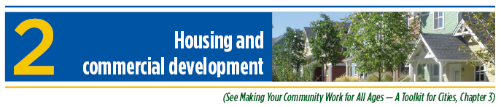
Provide age-friendly housing options.
Studies document that older citizens wish to “age in place.” Buyers and renters of all ages are becoming wary of the costs of commuting long distances. Communities that provide a range of age-friendly housing options will retain their older adult residents and provide an attractive alternative for all ages looking for housing.
Cities have a role in the siting and design of housing and commercial development through their planning and regulatory processes. Through these processes, cities can impact how well development meets the needs of all populations.
Policy
2-A The city conducts an audit of its development codes to ensure that a range of housing options are allowed, particularly in places connected to public transit, employment centers and community services.
___ Existing policies. (Please cite and attach copies for documentation.)
Use this space to record notes and progress.

2-B The city has in place policies to allow for and encourage a range of housing options, including accessory and shared dwellings that meet the needs of all ages and generations.
___ Existing policies. (Please cite and attach copies for documentation.)
Use this space to record notes and progress.

2-C The city evaluates and streamlines its building code review processes to be consistent with adopted plans and policies, including those that reduce costs and provide housing in a range of cost points.
___ Completed. (Please provide documentation.)
Use this space to record notes and progress.

2-D The city has in place policies that encourage developers to include features in new or restored housing stock that meets the different mobility needs of as many people as possible. Cities may refer to universal design, enabling design, visitability features or other design elements.
___ Existing policies. (Please cite and attach copies for documentation.)
Use this space to record notes and progress.

2-E The city evaluates its zoning and building code review processes to ensure that the siting and design of commercial properties consider the needs of users of all ages.
___ Completed. (Please provide documentation.)
Use this space to record notes and progress.

Action
2-F The city uses its property maintenance enforcement to support neighborhood quality and, as appropriate, assists property owners in identifying resources to maintain their homes.
___ Completed. (Please provide documentation.)
Use this space to record notes and progress.

2-G The city and its partners make information available about housing options within the city that meet different mobility and dependence levels.
___ Completed. (Please provide documentation.)
Use this space to record notes and progress.

2-H The city has a property tax relief program for homeowners with a fixed income who meet defined criteria (if allowed under state law).
___ Completed. (Please provide documentation.)
Use this space to record notes and progress.

2-I The city and its partners offer residents information about assessing and protecting their property to strengthen crime prevention.
___ Completed. (Please provide documentation.)
Use this space to record notes and progress.

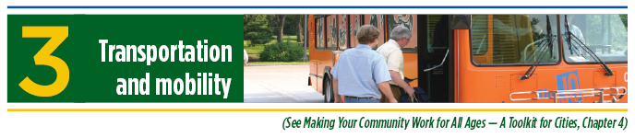
Ensure that the community transportation system meets the needs of all users.
Healthy, vibrant communities provide multiple, accessible transportation options that contribute to the independence of all residents. Young adults, baby boomers and all ages increasingly seek and choose communities where they can walk, bike or access transit to get to school, work, services and entertainment.
There are many resources available to help a city meet this criterion, including guidelines and checklists provided by the National Complete Streets Coalition (www.smartgrowthamerica.org/complete-streets), U.S. Department of Transportation National Highway Traffic Safety Administration Bikeability Checklist (www.nhtsa.gov/people/injury/pedbimot/bike/bikeability/); Bicycle Friendly America (www.bikeleague.org/bfa); and Walk-Friendly Communities. (www.walkfriendly.org/). These guidelines help communities ensure that the transportation system meets the needs of all users. Cities can work proactively with local transit operators to plan and implement transit services to address the needs of their residents
and workforce.
Policy
3-A The city addresses multiple transportation modes in its comprehensive plan.
___ Included in city plans. (Please cite and attach copies for documentation.)
Use this space to record notes and progress.

3-B The city has adopted a Complete Streets resolution or comparable policy and is taking steps to implement the policy.
___ Existing policy. (Please cite and attach copies for documentation.)
Use this space to record notes and progress.

3-C The city — with or without a transit partner — works to ensure public transportation stops and stations have infrastructure that meets the needs of all ages and abilities. Examples include: shelter with lighting, benches and curb cuts.
___ Completed. (Please provide documentation.)
Use this space to record notes and progress.

3-D The city and its partners review and consider adoption of older driver and pedestrian safety provisions in the region’s long-range safety plan. The city may use Toward Zero Deaths 2013–2017, or other recognized standards as guidance.
___ Included in city plans. (Please cite and attach copies for documentation.)
Use this space to record notes and progress.

Action
3-E The city works with partners, including transportation providers, to develop and implement strategies to support independence of non-drivers and those with additional needs for assistance in using transportation options.
___ Completed. (Please provide documentation.)
Use this space to record notes and progress.

3-F The city and its partners provide resource information on where residents can find transportation options.
___ Completed. (Please provide documentation.)
Use this space to record notes and progress.

3-G The city constructs pedestrian facilities to allow for safe travel to transit stops and stations from neighborhoods and other locations.
___ Completed. (Please provide documentation.)
Use this space to record notes and progress.

3-H The city and its partners provide resource information for determining older driver competency and the supports available for transitioning from driver to passenger.
___ Completed. (Please provide documentation.)
Use this space to record notes and progress.

3-I The city has considered application for or has achieved the Walk-Friendly Community designation from the Pedestrian Bicycle Information Center. (www.walkfriendly.org)
___ Completed. (Please provide documentation.)
Use this space to record notes and progress.

3-J The city has considered application for or has achieved the Bicycle Friendly Community designation from the League of American Bicyclists. (www.bikeleague.org/bfa)
___ Completed. (Please provide documentation.)
Use this space to record notes and progress.

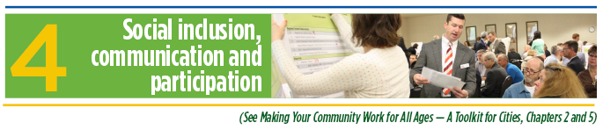
Include all residents in developing community activities and adapt communication strategies for multiple audiences.
By leveraging the knowledge, skills and abilities of all residents and including them in decision-making, communities create a competitive advantage for themselves. Cities will benefit when residents of all ages are an integral part of a community and the cities are knowledgeable about their diverse needs.
Meaningful participation in affordable community activities helps residents to develop relationships, maintain good health and have a sense of belonging. Cities obtain input from all residents to develop community activities that will engage residents and meet their needs.
Policy
4-A The city and its partners understand the demographic makeup of residents, engages with the community and then designs programming, including recreational opportunities and emergency planning activities, that respects the needs and interests of diverse populations.
___ Completed. (Please provide documentation.)
Use this space to record notes and progress.

4-B The city has a comprehensive communication plan with marketing and outreach strategies and tools that include diverse public imagery, depicting all ages, cultures and abilities.
___ Included in city plans. (Please cite and attach copies for documentation.)
Use this space to record notes and progress.

4-C The city communications plan requires that information about accessibility of facilities and transportation options is included when publishing information about city activities and events.
___ Included in city plans. (Please cite and attach copies for documentation.)
Use this space to record notes and progress.

4-D The city has adopted and implements an emergency management plan, or has adopted and implements the county emergency management plan. The plan includes strategies on mitigation, preparedness, response and recovery.
___ Included in city plans. (Please cite and attach copies for documentation.)
Use this space to record notes and progress.

Action
4-D The city communication plan includes strategies to work with partners to inform people at risk of social isolation about community activities and events.
___ Included in city plans. (Please cite and attach copies for documentation.)
Use this space to record notes and progress.

4-E The city partners with community organizations to develop and implement opportunities for utilizing and showcasing the skills and contributions of all ages, cultures and abilities.
___ Completed. (Please provide documentation.)
Use this space to record notes and progress.

4-F The city works with local, regional and state partners to educate residents about emergency/disaster preparedness planning. Partners may include MARC’s Metropolitan Emergency Management Committee (MEMC), the Community Disaster Resiliency Network (CDRN), home-delivered meals programs, community-based organizations, school districts, faith communities, retirement communities and others.
___ Completed. (Please provide documentation.)
Use this space to record notes and progress.

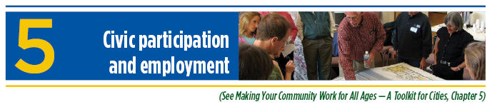
Provide opportunities for residents to be involved and keep all residents informed of city affairs and of employment and volunteer opportunities and other ways to be engaged.
With increased levels of involvement in community affairs and civic life, citizens are well positioned to build connections and support communities for all ages.
Cities will benefit from welcoming residents to be employed or become involved in city affairs. Input and participation from residents of all ages will strengthen the city’s programs and services.
Policy
5-A The city has a policy in place to encourage civic participation by all age groups in the community.
___ Existing policy. (Please cite and attach copies for documentation.)
Use this space to record notes and progress.

Action
5-B The city maintains and promotes a list of volunteer and employment opportunities within city government and offers an easy means to apply, including drop in, mail, on line and telephone.
___ Completed. (Please provide documentation.)
Use this space to record notes and progress.

5-C The city provides flexible options for volunteers of all ages and abilities, including training, recognition and guidance.
___ Completed. (Please provide documentation.)
Use this space to record notes and progress.

5-D The city encourages stakeholders, community organizations and nonprofits serving its community to work with volunteers of all ages, cultures and abilities, using best practices and guidelines for volunteer engagement and management promoted by organizations such as the Shepherd Center’s Coming of Age, the United Way of Greater Kansas City, United Way of Wyandotte County and Nonprofit Connect.
___ Completed. (Please provide documentation.)
Use this space to record notes and progress.

5-E The city and its partners encourage local businesses to adopt flexible employment practices to meet the needs of citizens of all ages.
___ Completed. (Please provide documentation.)
Use this space to record notes and progress.

5-F The city and its partners develop an outreach plan to ensure residents of all ages are included in community and civic conversations.
___ Completed. (Please provide documentation.)
Use this space to record notes and progress.

5-G The city ensures that meeting locations are accessible to all residents and meet the communication needs and challenges of diverse populations.
___ Completed. (Please provide documentation.)
Use this space to record notes and progress.

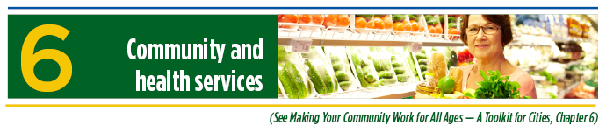
Offer a range of community and health services that address the needs of all ages.
Many residents desire easy access to a range of health and social services. Communities that address the community and health services needs of residents can generate value from both a real estate and a community health perspective.
Local governments may offer a range of direct services at their public facilities or work with private for-profit or nonprofit providers to deliver services using city facilities. In some cases, communities identify health needs and encourage private providers to locate programs and services in the city.
Policy
6-A Applicable city plans recognize the need for health care services that are accessible to all residents and served by transportation options.
___ Included in city plans. (Please cite and attach copies for documentation.)
Use this space to record notes and progress.

Action
6-B The city, in partnership with area health care organizations, makes arrangements to offer health services at community facilities. Examples include: hearing tests, hearing aid cleaning, flu shots, blood pressure checks, etc.
___ Completed. (Please provide documentation.)
Use this space to record notes and progress.

6-C The city, in partnership with the local public health department, publicizes plans and services to improve the rate of immunizations among city residents.
___ Completed. (Please provide documentation.)
Use this space to record notes and progress.

6-D The city has educated personnel to ensure those who work with the public are knowledgeable about specialized needs for citizens of different ages and abilities. Personnel are also trained in applicable reporting requirements of abuse or neglect, regardless of age.
___ Completed. (Please provide documentation.)
Use this space to record notes and progress.

6-E The city promotes and enables the location of full-service grocery stores and retail establishments to expand the availability of healthy food options.
___ Completed. (Please provide documentation.)
Use this space to record notes and progress.

6-F The city works with local ambulance providers to ensure city demographic information is incorporated into planning for services.
___ Completed. (Please provide documentation.)
Use this space to record notes and progress.

6-G The city, in partnership with area health care organizations, has developed and implemented education programs about healthy choices and preventive services, including the benefit of smoking cessation.
___ Completed. (Please provide documentation.)
Use this space to record notes and progress.

6-H The city encourages healthy eating by providing information to residents about programs such as home-delivered meals, food banks or other resources.
___ Completed. (Please provide documentation.)
Use this space to record notes and progress.

6-I The city encourages healthy eating and community participation by supporting community gardens and other initiatives that promote healthy eating.
___ Completed. (Please provide documentation.)
Use this space to record notes and progress.

6-J The city and its partners provide referrals to those residents identified as needing more intensive services.
___ Completed. (Please provide documentation.)
Use this space to record notes and progress.

