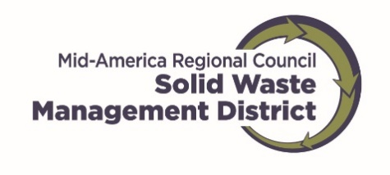
How-To
Invoice for Reimbursement

MARC Solid Waste Management District grant funds are released through a reimbursement process.
Invoices do not have a deadline (except for at the end of the project period.) If you want to submit monthly invoices, please contact district staff.
To receive payment for approved expenses incurred, please provide the following:
- Invoice Form. This can be found on the MARC website. Search Grantee Resources.
- Receipt/invoice for service/items you paid for
- Proof of payment. This can be a copy of cancelled checks; bank statements showing funds were withdrawn; credit card statements (must show charge and following statement showing charge was paid for).
- For salaries, please provide paystubs or other documentation to demonstrate salary was paid.
Remember to have your authorized official sign and date the invoice.
If your project required bids, please include them with the invoice if they were not already provided.
Please send invoices in the regular mail.
Match:
Match must also be documented. It is not required to include match on each invoice. If volunteer time is used as match, please provide documentation indicating hours and value of time spent, with the volunteer signature.
Security Interest Agreement:
If your project involved the purchase of equipment $5,000 or more, a security interest agreement will be required. Staff will prepare and provide you the agreement.
A sticker indicating the funders and an internal serial number will be provided for applying to the equipment.
After the project period is over, you will be required to submit an annual report for 4 or 6 years, depending on the dollar amount awarded. The report will include the tonnages diverted as a result of the equipment, condition of the equipment, and proof of insurance. Staff will contact you and e-mail the report form.
Every two years district staff is required to photograph the equipment.

